What is Culture?

Culture is the patterns of daily life learned consciously and unconsciously by a group of people. These patterns can be seen in language, governing practices, arts, customs, holiday celebrations, food, religion, dating rituals and clothing, etc.

Culture Shapes . . .

- The way we think (cognition)
- The way we interact (behavior)
- The way we communicate (language)
- The way we transmit knowledge to the next generation (education)
Adapted From Catherine Collier, 1998

Iceberg of Culture

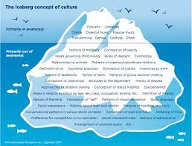

Surface Culture

- Music, visual and performing arts, drama
- Holiday celebrations and folklore
- Food/drink
- Traditional dress
- Historical contributions
- Outward displays of behavior and identity

Deep Culture

- Thoughts, beliefs, superstitions, religion
- Concerns, hopes, fears, worries, ethics, and how you organize your thinking and world
- Symbolic and intangible aspects of identity
- Subtle interpersonal relationships as expressed in actions and words
- Day-by-day details of life as it is lived

