Racial Cultural Identity Development
(Adapted from Louise Derman Sparks ABE)

Infants

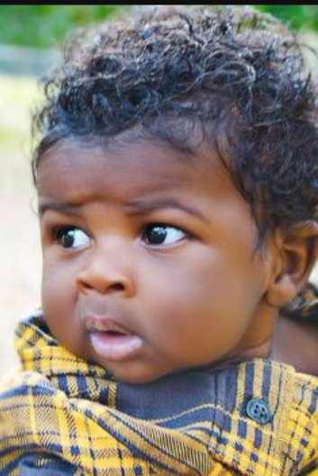
- Gradually becoming aware of self as a separate being.
- Beginning to absorb a cultural identity through daily caregiving interactions, household smell, sounds, etc. Beginning to babble a range of sounds and imitating intonation and sounds of the home language
- Beginning to notice and respond to skin color cues ( around 6 months old)

Toddlers and Twos

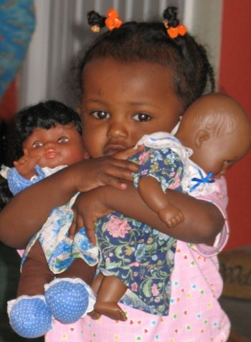

- Continuing to develop their awareness of self as separate individual
- Learning to interact with others within the cultural rule system of their families. Pays close attention to adults non-verbal messages
- Curious about physical characteristics of self and others (skin color, hair texture, etc.) May “match people based on physical characteristics
- Sometimes shows discomfort around unfamiliar people, including those with a skin color different from theirs.

3-5 year olds

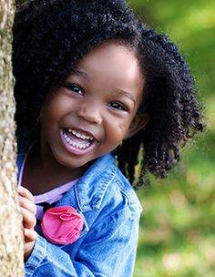
- Identify and match people according to “racial” physical characteristics and groups. Is often confused about the complexities of group categories
- Unsure about racial identity constancy
- Absorbs societal stereotypes from people and from media about other groups and may show discomfort or fear. May tease or refuse to play with others because of skin color.
- May begin to show evidence of societal messages affecting how they feel about their self identity and/or group identity

